Apostolic Incarnational Prayer

We are three elderly sisters, living in a Town House, in a retirement community. Our neighbors are all aware that we are the Contemplative Branch of the Sisters of the Good Shepherd. They respect our enclosure and we in turn have the name of each household living on our street and at our Morning Prayer we pray for a different household and their extended family by name and remember them in our Apostolic Incarnational Prayer. We lease a space, next to the delivery dock, for our Altar Bread Distribution, in the large building that accommodates independent, assisted, and full care residents. When meeting a resident in the hallways we greet them with a cheerful “Good Morning” a smile, ask God’s blessing upon them, and tell them to have a good day. A worker that we see every morning has told us “You make my day with your smile and greeting, thank you!
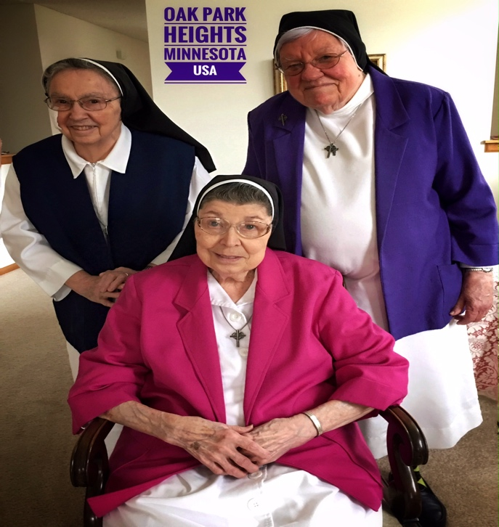
Our Vow of Zeal is our Apostolic Incarnational Prayer that is put into action; it motivates us to offer our all for everyone who is involved with our Apostolic Sisters Programs and also their varied ministries. St. Mary Euphrasia founded us to be the prayer support— prayer power behind our entire International Congregation or to put it another way, the praying heart of the Congregation.

Our Charism of Mercy and Reconciliation or Compassion, is the center of our Vowed life. Zeal motivates all we are and do; it gives us an inner peace and freedom to keep reaching out to the entire world’s problems, anxieties, sorrows, hope etc.

Silence, solitude, and enclosure strengthen and nourish our prayer and become God’s tender word of encouragement, mercy, forgiveness, reconciliation and peace. Our Prayer is a form of presence in the ministries of our Apostolic Sisters, it does not stop in the USA but goes out to the entire world where ever it is needed.

Living as Contemplatives Sisters in a secular retirement community is a challenge, a journey in different surroundings, that we believe Jesus is asking of us at this time, it enables us to be a visible witness to the people who live, work and visit the community and join us for the Eucharistic Celebration. Residents stop us in the halls or Chapel to ask our prayers for themselves, children, friends, etc. Where our hearts are, there is God, living in us and living our Vow of Zeal, reconciliation and compassionate mercy.

